**Posture Correcting AI Agent**

**VIVI**

**2018310412 Junseo Ko**

**2015311349 Dongwon Lee**

**2018312147 Yoonji Nam**

**Introduction**

**Problem Identification**

          The changes in posture, the position in which an individual maintains their body whilst standing or sitting, has been dynamically shifting throughout the century and retains itself as a pivotal factor in directly affecting our lifestyle behavior. Delving in, the modern work and lifestyle composes of sitting for long periods of time and over exceeds the recommended time regarding time spent sitting. In correlation, prolonged state of sitting leads to unhealthy stances specifically regarding the neck and spine, which causes an increased risk of developing health problems and musculoskeletal discomfort. According to a survey conducted by WellnessHealth [1], people habitually sit on average 13 hours a day, leading to development of health issues such as postural pain, hyperflexion injury, and various muscle and tendon aches. Moreover, with the increased exposure and usage of smart devices, the direct application of muscular and skeletal discomfort aligning with a mere comfortable position remains as a controversy in modern time in correcting and living a healthy lifestyle.

To gain a more comprehensive intuition upon the postural behavior and health issues diagnosis in office workers and students, there is an objective and non-aversive means of recognizing the shifts and corresponding with sitting behavior. In coordination with exponential upsurge of health issues relating with posture and variation to our current style of living, an interpreting tool to provide more detailed patterns of sitting throughout the day is required. In order to prevent to unnecessary hazard of having to treat with drugs and surgeries, a system inducing the correction of posture habits and prevent more serious illness is essential in enhancing current status of modern health and wellness.

**Targeted Audience**

          As mentioned above, the changes in the workforce plays a critical role in directly affecting our posture. For example, due to protracted hours and administrative work, office workers periodically spend their time working long hours in front of a computer. Due to the static aspect of sitting, the level of tension in the body causes fatigue and, with inadequate rehabilitation, can affect in long-term health problems. Likewise, students are also mainly subjected and affected by this notion. Students learn and retain knowledge in an environment where they are obligated to remain seated for long periods of time with distressing equipment. More relevantly, due to the impact of COVID-19 and the era of Zero Contact, students practice inappropriate posture with the increased application of indirect classes via computers, which not only deteriorates healthy wellbeing, but also reduces their efficiency in their ability to maintain focus. In conclusion, our project focuses on students and office workers who are objected to remain seated and therefore attain postural dysfunction.

**Solution**

To aid people in making a habit of the right posture, we designed VIVI to identify people's posture and provide reliable feedbacks. The posture will be identified through the camera with AI that has learned of bad posture. It will notify the user by using the app when the user's posture is bad. In addition, stretching and simple exercises will be presented to help with persistent bad postures.

**Related Work**

**1. CNN based learning model with Camera**

It uses laptop’s webcams and CNN network to detect turtle neck, filming images and videos from various backgrounds for one male and one female in their 20s, and creating a CNN-based learning model based on the data [2].

**2. Sitting Posture Recognition System using Flex Sensors.**

It recognizes the user's sitting postures using six flex sensors attached to the chair. The flex sensor is a system in which different resistance occurs depending on the shape of bending, and the resulting voltage is used as input to classify the posture through ANN [3].

**How to**

**Posture Capturing - Algorithm**

When a user powers on a laptop, a camera captures the user's posture with an image. Then, the AI detects each points of body by using Open-pose [4]. Lastly, using each features of body, the AI predicts whether that user’s posture is good or not.



**Notification**

There are two main methods of notification based on AI's analysis. The first, when VIVI captures a posture through a camera, the agent notifies in real time through an icon on the display of a computer or a laptop. The icon is always on display and user can move it anywhere on screen. The color of the icon changes related to user’s posture. If user’s posture is good or fixated, the color of icon is blue. However, if user’s posture is bad, then the color of icon changes to pink with three flickers to notify the changing. The last black icon relates to the camera being powered off. In this way, we can eliminate the interruptions or annoyances caused by continuous pop-up alerts and give users a convenient notification.

The second method of notification is to send pop-up messages according to the time selected by the user. The message informs users of their device usage time and recommends simple stretching and relaxation. Notification with pop-up message would bother user. So, the time gap options for messages will be relatively large, such as 30 minutes, one hour, and two hours. Or this notification could be turned off. Also, if the first method is through the icon on the display of a computer or a laptop, the second method is to receive a notification through the display, smartphone, or smartwatch.

**My Posture Report & Exercising Recommendation**

After capturing the user's posture, VIVI analyzes the record in a user's own posture report. It shows what posture the user usually takes on a daily, weekly, or monthly basis and analyzes the user's posture habits and the ratio of good and bad postures taken by the user. The report reminds users of their posture from time to time by informing them of the results of their reports for a while on their smartphones at random times, in reference to the iPhone's screen time.

In addition, VIVI learns which muscles or body parts become strained by certain postures and can recommend stretching or exercises to help relax muscles.

**Prototype**

The main purpose of our application, VIVI, is focused on the optimizing user’s experience to make good posture habit through the implementation of notification with the basis of user-friendly settings to incorporate its elements. VIVI incorporates the taken images and validates each posture according to the set frequency, which would bolster the enhancement upon posture fixation. VIVI’s prototype interface focuses on setting that would observe and not interfere with user’s task.

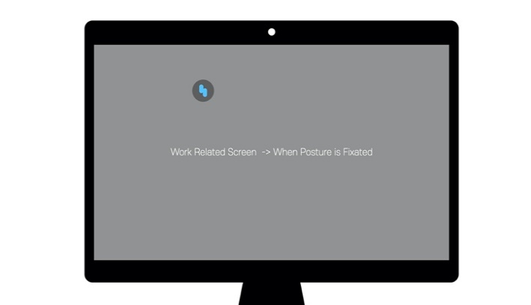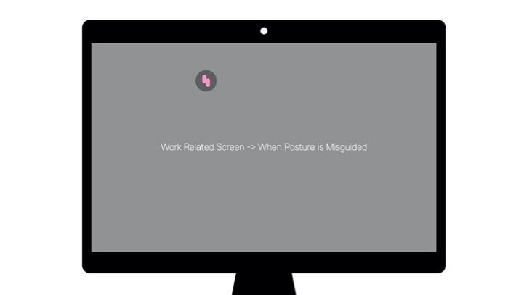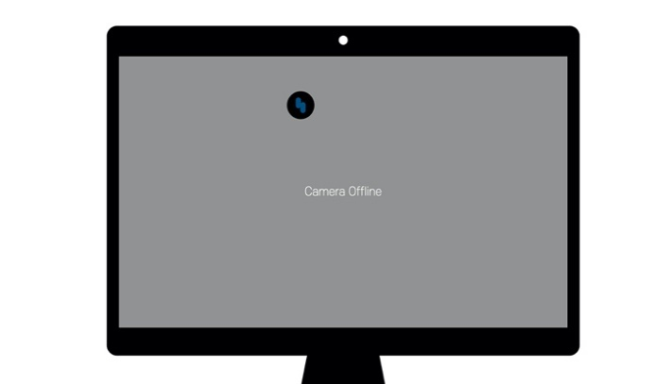

These icons that have different colors are the first way described earlier in notification and this is the state when our agent is usually used.

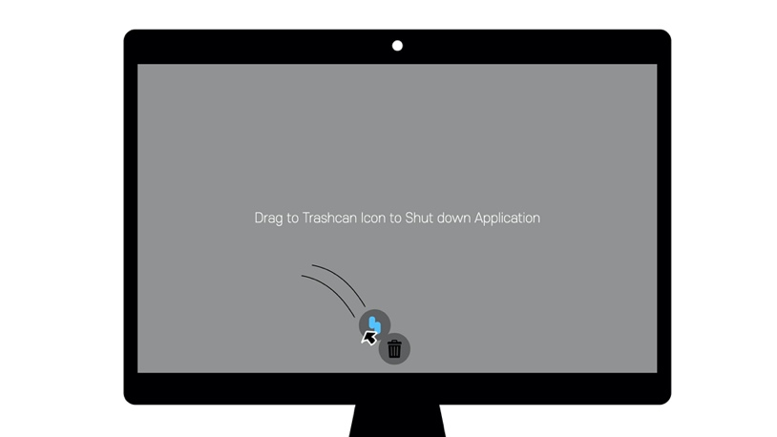

You can choose to shut down VIVI by moving icon into trash can.

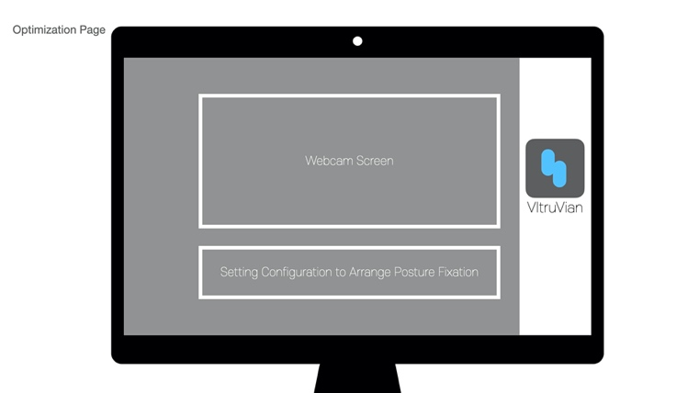

This is initial page of our agent. Through this page, the user can setup working environment just as the initial setting page of a smart phone and not appear again.

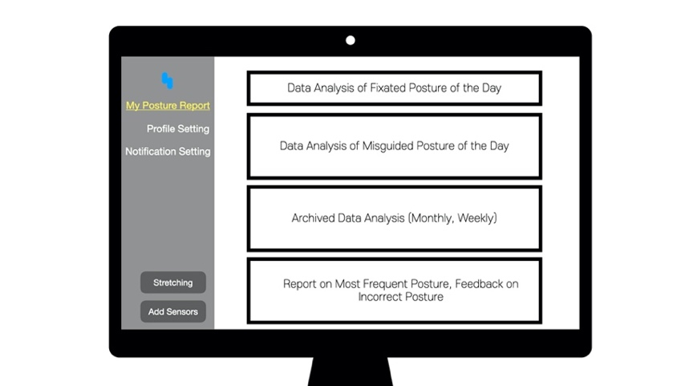The first page incorporates “My Posture Report”, in which users can see a report that the agent records about user’s posture. VIVI focuses on recording through the camera but epitomizes upon record statement and correctness of user’s posture, allowing for the prevention of data leakage. The application does not save captured recordings but serves its purpose by using the images to analyze body posture.



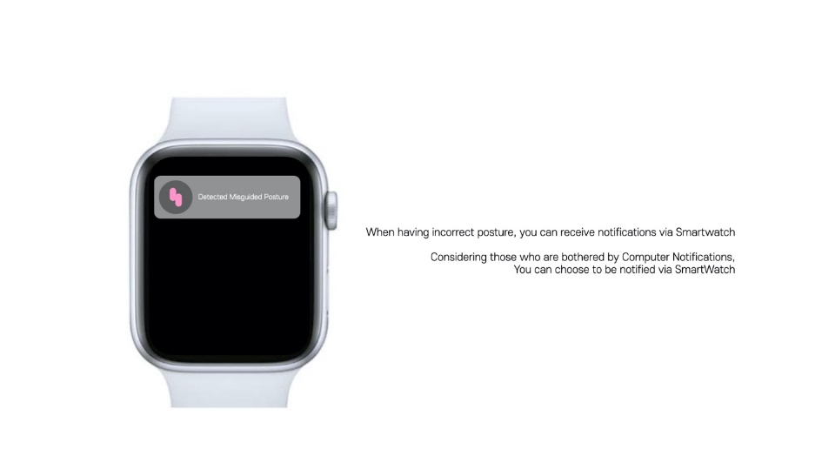The second page is “Profile Setting” where users can record their personal information and adjust the camera shutdown term. The next page is “Notification Setting” where users can set up the second notification method, pop-up messages, and notification of the report.

VIVI supports alarms via smart watch because pop-up on a screen of a laptop may cause disturbance to user.

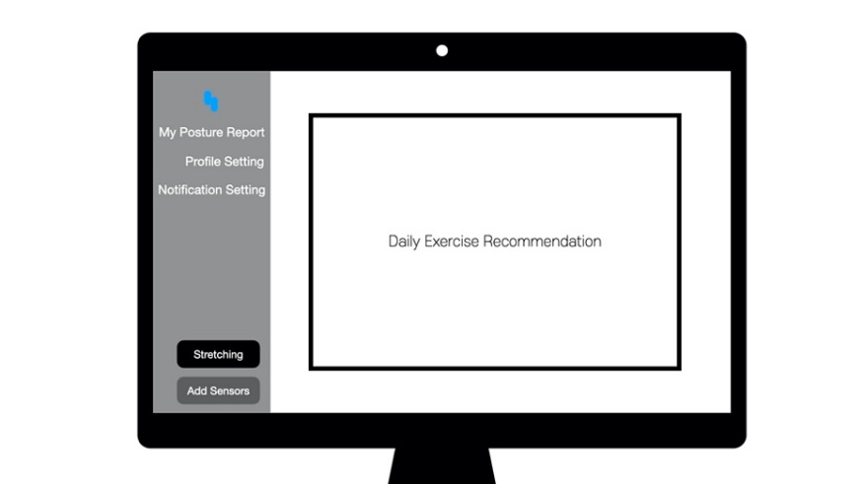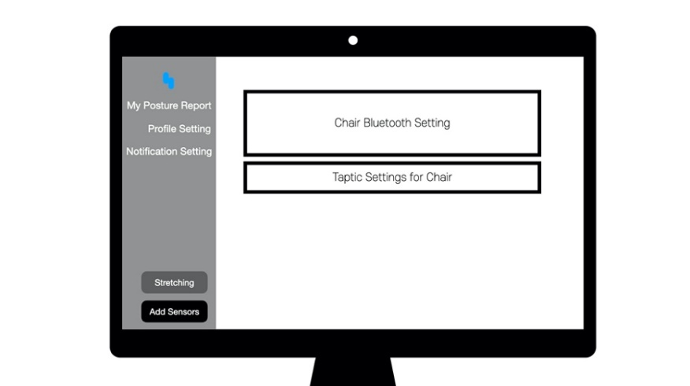

The left side recommends daily exercising. If user wants to stretch their body, VIVI supports it with various contents. The right setting is for adding extra chair for better accuracy.



For better accuracy, VIVI has an optional provision in connecting with a chair that has flex sensors as a means of extensive service. More detailed information about the implementation of chair with flex sensors is scrutinized in the following discussion section.

**Discussion**

**1. Security Issues**

When VIVI uses a webcam to check a user’s posture, people may be reluctant to use it because of issues regarding security. People have concerns about their photos or physical information being violated. Programs that use webcams tend to be linked with security issues like leakage or hacking. Taking reference to companies which collect a user’s health data like Apple or Samsung, the state of data as an encrypted state to protect personal information has been proven to work efficiently. Therefore, our service provides “**Internal** **Processing (On-Device AI)**” and “**Encryption**” as a means of safety and protocol.

**1 - 1 Internal Processing (On-Device AI)**

Many hacking and interception trials occur when an application sends information to a server. If a server is hacked or users’ data is intercepted, it will be leaked to someone else. So, our agent saves and processes data inside of each users’ local environment, not the server. This method comes from AI home agent “Ballie” made by Samsung. It follows and monitors users and house via camera. It will be dangerous if someone hacks Ballie’s camera and watches the user 24 hours. However, Samsung developed a technology, On-Device AI, which is processing all the data inside of the machine [5].

Our agent also uses similar technology as Ballie does. When a user downloads our AI agent application, AI model is distributed to each user’s local environment. Therefore, the application doesn’t require sending user’s data to the server, enabling the processing of personal data inside of personal devices. This method bolsters protecting data, and if promoted successfully, it would induce people to comfortably access its functions. However, if models are given to local devices, applications may be heavy and need lots of device memory and CPU power. So, in development, we have to use a shallow model such as MobileNet [6] which is developed for the mobile environment.

**1 - 2 Encryption**

We also designed an application that saves all the data as encrypted format. So, without personal key and application, hackers cannot browse user’s data. We encrypt text data [7] and image data [8].

**1-3 Reluctance to Camera**

Coherent to the question of privacy and security relating with the usage of camera and personal data, the aversion of being in a state of exposure is apparent and a critical obstacle that is in need of resolving in order to fully optimize user’s experience and meet the need of assurance in our service application. Despite the utilization of internal processing and encryption used to further enhance the security of our services, many users do not discern to its complexity and safeguard due to the inability to participate and interact with the servers physically. To bolster the usage of our service while maintaining user’s credibility, our service adjusts to the usage of camera by automatically stopping from operating when there is no movement and adding an extension feature that would directly link with programs such as *Zoom* and *Webex*. With the settlement of Zero Contact era and the increase of usage in third-party Communication technology, people tend to feel safe in proceeding with their work and daily life routine while using these programs. Therefore, with the extension to third party programs, our application intends to aid in posture fixation while being able to process information and providing a sense of self-awareness to users by continuously displaying to a user their own live image. Therefore, the extension takes measure to condition and allow for the increase in validity and assurance in the use of our service and its security protocols, further allowing for the increased rate of using our services even without the extension in the future.

**2. Extension of Flex Sensor Chair**

VIVI allows for the extension of usage in flex sensors incorporated inside a chair. According to a scientific journal, flex sensors in AI allow for the detection of bad posture superior to that of just using a webcam [3]. The flex sensors located inside the chair will allow for a more extensive approach in fixating posture by transmitting a vibration located inside the sensors. We also recommend to use taptic motions that would serve to notify users upon irregular postures with anthropological methods. Taptic engine is developed by Apple and it is not some common vibration alert. It provides soft rendering of sensation, reducing the irritability of user’s environment caused by any regular vibrations. VIVI emphasizes upon flex sensor chair being an extensive service that would enhance the user’s experience however is not a mean of necessity.

**3. Why our agent is better than Upright Go**

Upright Go can be firsthand seen with better accuracy than our model because it uses a device that must be attached on the back. However, people have to buy a new device and without buying it, the application cannot be used. Furthermore, people go through the hindrance of manually attaching these devices on their back. In contrast, users can fully optimize our agent, VIVI, by simply downloading an application and don’t need to attach any accessories on their body, so it would be more comfortable to use.

**Conclusion**

We created VIVI, an artificial intelligence agent that corrects the user's posture through a webcam. If someone has turtle neck or disk because of bad posture, the person may have to spend lots of money and time correcting bones and posture by having manual therapy. However, VIVI will help users develop the habit of taking the right posture through user-friendly notification methods and My Posture Report. It will bring cost reduction from paying lots of money to manual therapy or surgery. Also, the user's personal information will be secure and VIVI can be used in a variety of ways with web meeting services and sensor chairs. Unlike other products that require additional devices, our agent VIVI, just using a webcam, will increase user participation with a simple and easy approach. VIVI emphasizes its relations to very realistic and engaging pain-points concerning modern audiences and environment. VIVI ensures the innovative changes and improvements that capture and enhances the lifestyle and wellbeing of its users.

**References**

[1] R. Castaneda. (2018, February 1) *10 Ways Poor Posture Can Harm Your Health. Accessed: [Online]*. Available: https://health.usnews.com/wellness/ slideshows/10-ways-poor-posture-can-%harm-your-health

[2] 한지예, 박진호 (2020). CNN기반의 학습모델을 활용한 거북목 증후군 자세 교정 시스템. 한국콘텐츠학 회논문지, 20(7), 47-55.

[3] Hu, Q., Tang, X., & Tang, W. (2020). *A Smart Chair Sitting Posture Recognition System Using Flex Sensors and FPGA Implemented Artificial Neural Network*. IEEE Sensors Journal, 20(14), 8007–8016. https://doi.org/10.1109/jsen.2020.2980207

[4] Cao, Z., Hidalgo Martinez, G., Simon, T., Wei, S.-E., & Sheikh, Y. A. (2019). OpenPose: Realtime Multi-Person 2D Pose Estimation using Part Affinity Fields. IEEE Transactions on Pattern Analysis and Machine Intelligence, 1. <https://doi.org/10.1109/tpami.2019.2929257>

[5] Hitti, N. (2020, January 8). *Ballie the rolling robot is Samsung’s near-future vision of personal care*. Dezeen. https://www.dezeen.com/2020/01/08/samsung-ballie-robot-ces-2020/

[6] Andrew G. Howard (2017, April 17) *MobileNets: Efficient Convolution Neural Networks for Mobile Vision Applications*

[7] Jing, X., Hao, Y., Fei, H., & Li, Z. (2012). *Text Encryption Algorithm Based on Natural Language Processing*. 2012 Fourth International Conference on Multimedia Information Networking and Security, 346, 153–157. https://doi.org/10.1109/mines.2012.216

[8] Xu, M. (2015). *A Modified Chaos-Based Image Encryption Algorithm*. Journal of Software, 10(8), 931–938. <https://doi.org/10.17706//jsw.10.8.931-938>